**Strength and Fatigue Analysis of**

**Welded joint using Ansys**

**M. Tech. Scholar Mohammad Imran, Prof. Dr. Ram Gopal Verma**

Department of Mechanical Engineering,

Rajshree Institute of Management and Technology,

Bareilly,India

**Abstract- Failure of welded frames / machine components results in various direct losses, such as the cost of repair, the cost of the operation to prevent possible failure, and injury insurance, as well as indirect losses, such as a reduction in productivity and a negative impact on the company's image. To determine the significance of stress and deflection under particular loading conditions, welding simulation was carried out experimentally and using the Ansys software in this study. We create welded joints in Solid works CAD programme and then import the joint assembly. We used ANSYS to analyses the strength parameters of welded joints made of mild steel and weld materials made of aluminum alloy and mild steel using gas metal arc welding (GMAW) on them, as well as perform fatigue testing, so that we could apply load conditions to these joints that caused stress and deformation, fatigue life, and joint damage by changing the weld bead thickness from 3 mm to 5 mm and 7 mm. The whole study will be carried out using 'ANSYS workbench,' which will evaluate their performance curves and outcomes.**

**Keywords: Strength parameter, Fatigue testing, Finite Element analysis, CAD, ANSYS, Mild steel, Structural steel, Lap or L joints.**

**I. INTRODUCTION**

Steel structures require a number of joining methods, including welding, which is used for a variety of purposes. It has to do with the right amount of time to complete the procedure as well as the expense of a high-quality result.

These constructions are exposed to changing load segments during their life cycle as a result of the outside environment (for example, wave and wind sway). To guarantee basic quality, welded joints in frameworks subjected to fatigue stresses are put to the test.

This scenario requires a comprehensive knowledge of the fatigue behavior of welded joints. Weakness tests are the most accurate method for assessing this behavior, but they involve a considerable commitment of time and money, making this arrangement inappropriate for the vast majority of

modern steel development components. Welding is a material joining method that involves heating materials to suitable weight temperatures or by weight alone, with or without the addition of filler material, to form a combination of materials. Sweat is used to make joints that endure a long time. It is used to choose automobiles, aircraft designs, railway vehicles, equipment tracks, assistant works, tanks, furnaces, and boilers, among other items.

Welding is a manufacturing or construction technique that connects materials, typically metals or thermoplastics, by forming an unmistakable connection that is distinct from brazing and fastening and does not, for example, split apart base metal at low temperatures. A filler material is constantly injected into the joint to define a fluid body (the slurry body), which cools to create a joint as solid as the foundation material. Weight may also be used to move a weld that is heated or that is not in the presence of anybody else.

## 1. Definition of Welding:

"Welding is the technique of connecting two pieces of metal such that they remain together at their extraordinary breaking point surfaces," according to Wikipedia. When two areas to be solidified are melted, with or without the inclusion of metal for a metallic bond game plan, warmth or pressure, or both, is supplied.

## 2. Need for Welding:

Total automated or robotized welding structures have foreseen an obvious future in the welding industry, with an ever-increasing need for both high speed and precision. The rate at which robotization is being introduced into the welding process is astonishing, and it is conceivable that by the end of this century, welding production units may have more automated robots than people.

PCs are also anticipated to play an important part in the operation of automated welding structures, with demands coming from activities that need counts of welding factors as numerical conditions. To achieve perfect mechanical quality in welded connections, robotized structures need a high level of confidence in anticipating weld limits.



Fig 1. Weld Zones.

## 

## 3. Welding classes:

The general welding classes available are B, C, and D. The amount of defects in the weld, as well as internal and external misalignments of the base material components, is shown in the weld class. Welding Class B has the fewest misalignments and, thus, does not need post-treatment.

When there are a lot of fatigue loads, a lot of risk zones, and a lot of brittle fractures, Class B is used. Class C does not need any post-welding treatment. It takes less time to complete than class B. Welding class C is commonplace at BT Products. Class D welds are those that are not subjected to substantial loads.

**II. MODELLING OF WELDED JOINTS**

Changing the geometry to generate a few faulty parts is the first step in the simulation. Structural steel is used for the plate material and welds. The welding model's actual materials were aluminum alloy and mild steel; the simulation material was mild steel since it has the best mechanical properties and is accurate enough. In the meshing procedure, the element type Hex dominating is utilized.

It ensures that Hex elements, as well as other components, are used to fill in the gaps in the geometry to the greatest extent possible. Each component's initial thickness sizes are 3 mm, 5 mm, and 7 mm. After the problem has been resolved, the components' sizes are changed to ensure that they are suitable. In this research, a variety of geometrical assemblages were modeled.

The first set is a standard' L' joint, as indicated in the diagram, which is defined by the solid work and plate dimensions. Second, a butt joint was constructed for assembly. The thickness of the beads ranges from 3 mm to 7 mm.

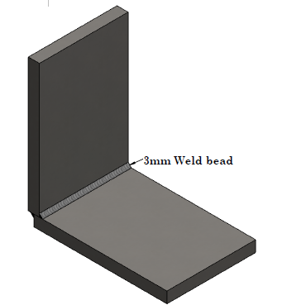

1. Welded ‘L’ joint

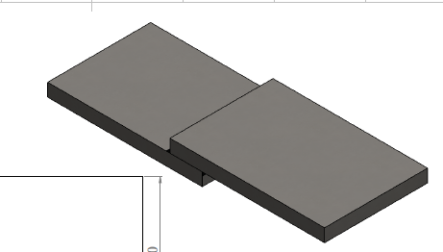

(b) butt joint

Fig 2. Weld joints.

## 1. Dimensions of joints:

The weld technique is used to connect two plates together. The L joint is made up of 120 mm x 80 mm x 10 mm thick plates that are connected together. A 45o chamfer is supplied, with a chamfer of 4mm x 4mm. Butt' joint plate dimensions are 120 mm x 80 mm x 10 mm thick plates linked together by a weld technique to create a junction shape. Weld beads come in three different thicknesses: 3mm, 5mm, and 7mm.

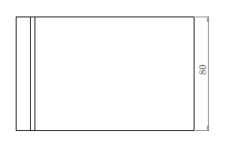 (a)

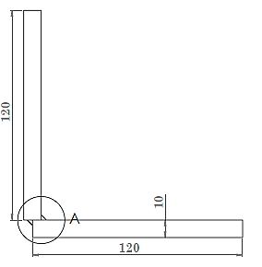

(b)

Fig 3. Dimensions of ‘L’ joint.

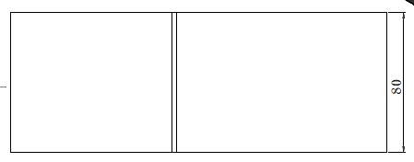

(a)

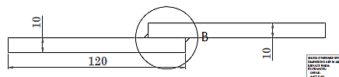

(b)

Fig 4. Dimensions of Lap joint.

**III. MATERIALS AND METHODS**

Mild steel and Aluminum alloy considered as material for filler in present study. Structural steel material considered for metal plates. Properties of material are described below.

Table 1. Material properties.

|  |  |  |  |
| --- | --- | --- | --- |
| Para  meters | Mild steel (weld Material) | Aluminum alloy (weld Material) | Structural steel (Plate Material) |
| Density (Kg/m3) | 7860 | 2700 | 7850 |
| Young's Modulus (MPa) | 2.1 ×105 | 69000 | 20000 |
| Poisson's Ratio | 0.303 | 0.33 | 0.29 |
| Bulk modulus (GPa) | 177 | 67 | 140 |
| Shear modulus (GPa) | 80 | 25 | 81 |
| Yield Strength (MPa) | 370 | 55.15 | 250 |
| Ultimate Tensile Strength (MPa) | 440 | 124 | 460 |

In ANSYS, the approach used for static restricted component analysis of welded joints. Limit circumstances, coincided models, and the effects of welded 'L' and Lap joints are also investigated.

While welding offers many unique advantages over other joining methods, it also has a number of significant disadvantages, including residual stress evolution and solder deformities.

The effects of welding input circumstances may be readily predicted using simulation techniques such as the Finite Element Method for a low experimental cost. In a 3D finite element model, a study was performed to forecast the entire transient temperature fields of a Mild steel plate's base.

**IV. APPLYING BOUNDARY CONDITIONS**

The ‘L' joint and the Lap joint have boundary conditions imposed to them. One end of each joint was fixed, while the other end provided a 1000 N force operating vertically downward on the lap joint and horizontally rearward on the 'L' joint. Then, based on the loading behaviour, optimize the stress and deflection of the joint.

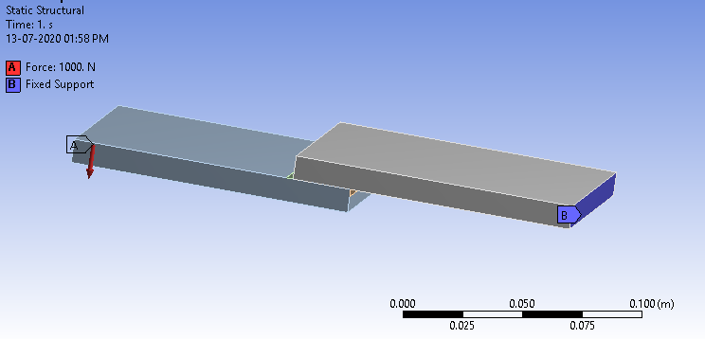

Fig 5. Boundary condition applied on Lap joint.

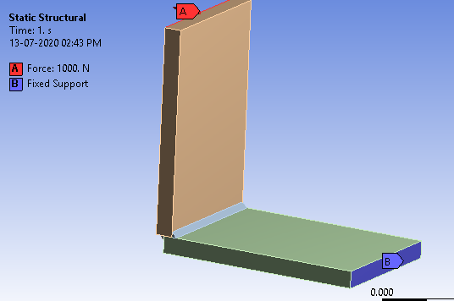

Fig 6. Boundary condition applied on ‘L’ joint (Corner joint).

**V, RESULTS AND DISCUSSION**

Equivalent stress, deflection, and strain produced under the load value examined have been given as results. Fatigue study was conducted on the 'L' joint and the butt joint, and factors of safety and fatigue life were maximized.

Both joints come in three different models with different weld bead sizes of 3mm, 5mm, and 7mm. In this research, two different kinds of fatigue loading were used: completely reversed loading and zero-based loading.

The total deformation, stress, and strain produced under the load value evaluated have been given. Fatigue study was conducted on the 'L' and 'Lap' joints, and the factor of safety and fatigue life were optimized.

Both joints come in three different models with different weld bead sizes ranging from 3mm to 5mm. In this research, two different kinds of fatigue loading were used: completely reversed loading and zero-based loading.

After that, a fatigue study is created for optimum stress and deformation of the welded junction, and the findings are compared to optimize the welded joint strength.

### 1. Strength Analysis of Welded Lap joint in ANSYS:

**1.1 Deformation of Weld Lap joint of Aluminum alloy**

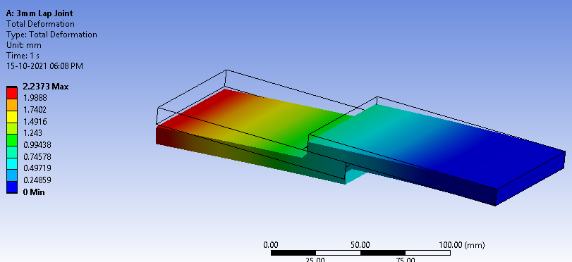

Fig 7. Total Deformation of Lap joint at 3mm weld bead thickness.

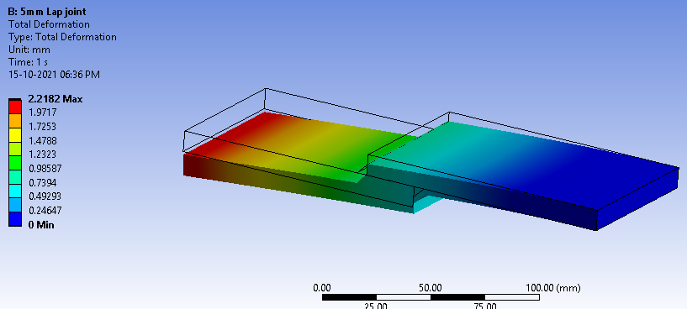

Fig 8. Total Deformation of Lap joint at 5mm weld bead thickness.

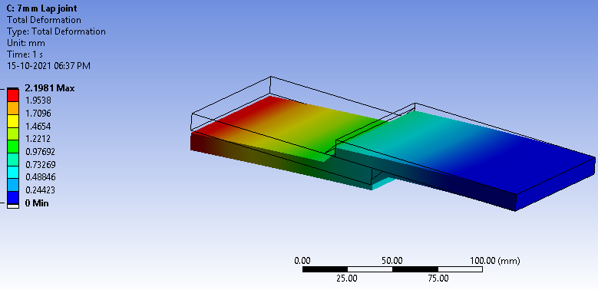

Fig 9. Total Deformation of Lap joint at 7mm weld bead thickness.

**1.2 Deformation of Weld ‘L’ Type joint of Aluminium alloy:**

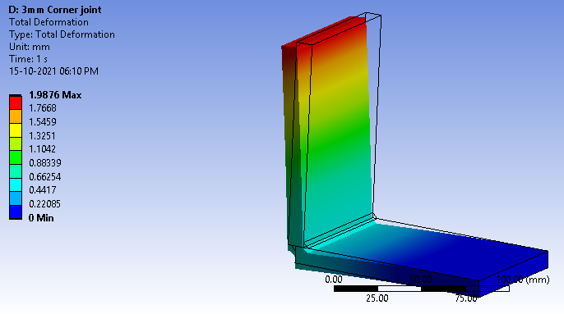

Fig 10. Total Deformation of ‘L’ weld joint at 3mm weld bead thickness.

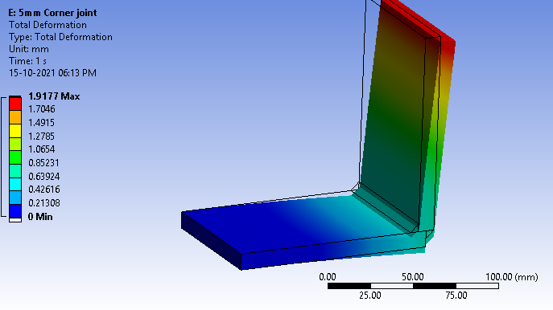

Fig 11. Total Deformation of ‘L’ weld joint at 5mm weld bead thickness.

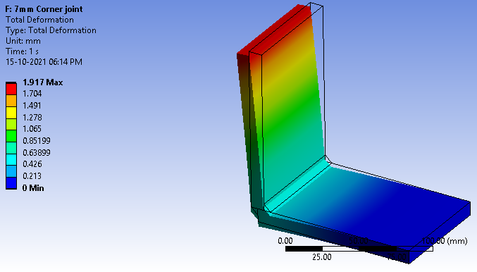

Fig 12. Total Deformation of ‘L’ weld joint at 7mm weld bead thickness.

### 2. Comparison of Strength parameter of Lap joint using Aluminum alloy as per thickness of weld bead variations:

**2.1 Using Aluminum alloy Material in Lap Joint welding:**

Table 2: Total Deformation and equivalent stress of Lap joint using aluminum alloyat 1000 N load

|  |  |  |  |  |
| --- | --- | --- | --- | --- |
| S.No | Force (N) | Weld Bead Thickness (mm) | Total Deformation (mm) | Equivalent stress |
| 1 | 1000 N | 3 | 2.23 | 111.99 |
| 2 | 1000 N | 5 | 2.21 | 63.97 |
| 3 | 1000 N | 7 | 2.19 | 63.39 |

Table 3: Strength Parameter of Lap joint using aluminum alloy at 1000 N load

|  |  |  |  |  |  |  |
| --- | --- | --- | --- | --- | --- | --- |
| S.No | Force (N) | Weld Bead Thickness (mm) | Shear stress (MPa) | Safety factor | Fatigue Life Max (Cycles) | Damage (Max) |
| 1 | 1000 N | 3 | 37.34 | 2.5 | 4.33E+06 | 230.5 |
| 2 | 1000 N | 5 | 24.39 | 4.37 | 1.00E+08 | 10 |
| 3 | 1000 N | 7 | 24.15 | 4.41 | 1.00E+08 | 10 |

**2.2 Using Mild Steel Material in Lap Joint welding**

Table 4. Total Deformation and equivalent stress of Lap joint using Mild steel at 1000 N load.

|  |  |  |  |  |
| --- | --- | --- | --- | --- |
| S.No | Force (N) | Weld Bead Thickness (mm) | Total Deformation (mm) | Equivalent stress |
| 1 | 1000 N | 3 | 2.22 | 160.05 |
| 2 | 1000 N | 5 | 2.19 | 155.27 |
| 3 | 1000 N | 7 | 2.16 | 145.58 |

Table 5. Strength Parameter of Lap joint using Mild Steel alloy at 1000 N load.

|  |  |  |  |  |  |  |
| --- | --- | --- | --- | --- | --- | --- |
| S.No | Force (N) | Weld Bead Thickness (mm) | Shear stress (MPa) | Safety factor | Fatigue Life Max (Cycles) | Damage (Max) |
| 1 | 1000 N | 3 | 60.33 | 2.31 | 3.76E+05 | 2657.1 |
| 2 | 1000 N | 5 | 52.53 | 2.38 | 4.76E+05 | 2138.4 |
| 3 | 1000 N | 7 | 52.85 | 2.54 | 6.53E+05 | 1531.1 |

Fig 13. Total Deformation of Lap joint.

The greatest deformation was observed in the lap weld joint at 3mm thickness, as seen in the graph. On a 7 mm weld bead thickness, the minimum distortion was discovered. Deformation was determined to be 2.21mm when utilizing a 5 mm thick weld bead, which is lower than a 3 mm thick weld but higher than a 7 mm thick weld bead.

On a 7 mm thick weld bead junction, the minimum distortion was discovered.

Fig 14. Equivalent stress of Lap joint.

As per graph it is found that maximum Equivalent stress is 160.5 MPa with mild steel material at 3mm weld bead thickness. 111.99 MPa stress found at 3mm weld bead with aluminum alloy material. Minimum stress found on 7mm thickness of bead.

Fig 15. Shear stress of Lap joint.

Fig 16. Safety Factor of Lap joint.

Fig 17. Fatigue Life Cycles of Lap joint.

Fig 18. Damage plot of Lap joint at 1000 N Load.

As per figure we found factor of safety maximum at 7 mm thickness of weld bead is 4.41 at aluminum alloy and 2.54 at mild steel of weld bead thickness. Fatigue life cycle found maximum on Aluminum material as compared to mild steel. Weld bead thickness o 7mm and 5 mm gives maximum value of fatigue life cycle.

**3. Strength parameter of ‘L’ joint Using aluminum alloy as per thickness of weld bead variations:**

**3.1 Using Aluminum alloy Material in ‘L’ Joint welding**

Table 6: Total Deformation and equivalent stress of ‘L’ joint using aluminum alloyat 1000 N load

|  |  |  |  |  |
| --- | --- | --- | --- | --- |
| S.No | Force (N) | Weld Bead Thickness (mm) | Total Deformation (mm) | Equivalent stress |
| 1 | 1000 N | 3 | 1.98 | 244.64 |
| 2 | 1000 N | 5 | 1.91 | 83.23 |
| 3 | 1000 N | 7 | 1.91 | 84.84 |

Table: Strength Parameter of ‘L’ joint using aluminum alloy at 1000 N load.

|  |  |  |  |  |  |  |
| --- | --- | --- | --- | --- | --- | --- |
| S.No | Force (N) | Weld Bead Thickness (mm) | Shear stress (MPa) | Safety factor | Fatigue Life Max (Cycles) | Damage (Max) |
| 1 | 1000 N | 3 | 57.54 | 1.14 | 4.50E+03 | 2.22E+05 |
| 2 | 1000 N | 5 | 32.37 | 3.36 | 9.58E+07 | 10.43 |
| 3 | 1000 N | 7 | 31.62 | 3.3 | 8.33E+07 | 12 |

**3.2 Using Mild Steel Material in ‘L’ joint welding:**

Table 7: Total Deformation and equivalent stress of ‘L’ joint using Mild steel at 1000 N load.

|  |  |  |  |  |
| --- | --- | --- | --- | --- |
| S.No | Force (N) | Weld Bead Thickness (mm) | Total Deformation (mm) | Equivalent stress |
| 1 | 1000 N | 3 | 1.93 | 231.34 |
| 2 | 1000 N | 5 | 1.86 | 169.61 |
| 3 | 1000 N | 7 | 1.86 | 168.08 |

Table 8: Strength Parameter of ‘L’ joint using Mild Steel alloy at 1000 N load

|  |  |  |  |  |  |  |
| --- | --- | --- | --- | --- | --- | --- |
| S.No | Force (N) | Weld Bead Thickness (mm) | Shear stress (MPa) | Safety factor | Fatigue Life Max (Cycles) | Damage (Max) |
| 1 | 1000 N | 3 | 97.98 | 1.59 | 1.34E+04 | 74802 |
| 2 | 1000 N | 5 | 47.9 | 2.18 | 1.93E+05 | 5169.7 |
| 3 | 1000 N | 7 | 46.8 | 2.2 | 2.22E+05 | 4491.8 |

Fig 19. Total Deformation of 'L' joint.

As per graph we found the maximum deformation in ‘L’ weld joint at 3mm thickness. Minimum deformation found on 5 mm and 7 mm weld bead thickness.

When using weld bead of 5 mm thickness deformation found 1.91 mm at aluminum alloy material which is lower from 3 mm thick weld and higher than 7 mm thickness of weld bead. Minimum deformation found on 7 mm thickness of weld bead joint.

Fig 20. Equivalent stress of 'L' joint.

As per graph we found Equivalent stress maximum on 3 mm thickness of weld bead and minimum value of stress found on 5mm and 7mm weld bead thickness.

Fig 21. Shear stress of 'L' joint.

Fig 22. Safety Factor of 'L' joint.

Fig 23. Fatigue Life Cycles of 'L' joint.

Fig 24. Damage plot of ‘L’ joint at 1000 N Load.

**VI. CONCLUSION**

Some of the basic parts are made of welded joints in holders, pressurized vessels, transport vehicles, earthmoving gear, rocket, and so forth. In the assembling and development of a few structures, butt welds and' T ' joints are the most widely recognized.

The broad capacity of butt welds in various structures, just as seaward and atomic, offers researcher wide extension for examining the activities under various stacking conditions [8]. Failure assessment of the components shows that the chief reason for most damaging Failure is exhaustion alone [14]. Regardless of whether the weariness of the sold metal is fine, there are issues.

There is a brisk change in the area which is brought about by inordinate weld recovery, undermining, layer incorporation and insufficient penetration. [7]

The structural use of aluminum alloys in functions like automobiles and trains, bridges, overland structures and high-speed ships is becoming more and more significant.

Sweating is the primary method of joining in all cases and fatigue is an important design criterion. It is, however, considered to have weak fatigue properties in weakened joints. Clear design procedure is therefore needed to prevent fatigue failures in the welded structures of aluminum alloys. In addition to the basic design of new structures, the methods to evaluate the remaining lives of existing structures are also of increased interest. [24]

This study suggested that the strength parameters of the butt-type welded joint were strongest as far as the mechanical properties of the weld joint were concerned.

### 

### 1. Results output for Lap welded Joint:

* As per deformation study by graph we found maximum deformation in Lap weld joint at 3mm thickness. Minimum deformation found on 7 mm weld bead thickness. When using weld bead of 5 mm thickness deformation found 2.21 mm which is lower from 3 mm thick weld and higher than 7 mm thickness of weld bead.
* Equivalent Stress optimization in Lap weld joint at 3 mm thickness found maximum as compared to other two. also, for 7 mm thickness of weld bead gives lower stress is 63.39MPa. so as per study of deformation and stress we found 7 mm thickness of weld joint gives better strength parameters.
* As per study minimum factor of safety found on 3 mm thickness of Lap weld joint and maximum factor of safety found on 7 mm thickness of weld bead joint.
* In fatigue life analysis using S-N curve analysis in ANSYS we found maximum value of fatigue life of all weld joint that is 4.33E+06 at 1000 N load.
* In Lap joint we found satisfactory results at 7 mm thickness of weld bead.
* As comparison of material used in weld bead are Structural steel and mild steel. In study we found aluminum alloy materials gives better results as compared to mild steel.

### 

### 2. Results output for ‘L’ type Welded Joint:

* As per deformation study by graph we found maximum deformation 1.98 mm in ‘L’ weld joint at 3mm thickness. Minimum deformation found on 5 mm weld bead thickness. When using weld bead of 5 mm thickness deformation found 1.91 mm which is lower from 3 mm thick weld.
* Equivalent Stress optimization in ‘L’ weld joint at 3 mm thickness found maximum 244.64 Mpa as compared to other two. also, for 5 mm thickness of weld bead gives lower stress is 83.23MPa. so as per study of deformation and stress we found 5 mm thickness of weld joint gives better strength parameters.
* As per study minimum factor of safety found on 3 mm thickness of weld joint is 1.14 and maximum factor of safety found on 5 mm thickness of weld bead joint is 3.36.
* Fatigue life cycle found maximum on 5 mm thickness of weld joint and minimum found on 3 mm thickness of weld bead joint, so as fatigue failure we can say that 5 mm thickness of weld bead L joint having higher number of life cycle during cyclic loading.
* In ‘L’ joint we found satisfactory results at 5 mm thickness of weld bead.

**VII. FUTURE SCOPE**

The mechanical characteristics and microstructure of the welded junction, as well as three additional dissimilar joints using different metals, were the focus of this research. Further research may concentrate on the corrosion behavior of these four dissimilar metal weld connections, which are more prone to corrosion. It is also possible to conduct a fatigue study of the welded joints and compare the findings.

Furthermore, further experimental work may concentrate on post-heating welded joints to enhance austenite content, which could aid in achieving acceptable corrosion resistance and mechanical characteristics on dissimilar welded joints. More research may be done on welding joint processes with various dissimilar metals, particularly in the aerospace industry, given the breadth of new development initiatives.

**REFERENCES**

1. Subramanian J, Supriyo Ganguly, Wojciech Suder, “Influence of welding processes on weld bead geometry”, International Research Journal of Engineering and Technology, Volume: 06, Issue: 01, 2019.
2. Manabendra Saha, S. S. Dhami, “Effect of TIG Welding Parameter of Welded Joint of Stainless Steel SS304 by TIG Welding”, Trends in Mechanical Engineering & Technology, Volume 8, Issue 3, 2019.
3. M.M. Alam, Z. Barsoum, P. Jonse´n. A.F.H. Kaplan, “The influence of surface geometry and topography on the fatigue cracking behavior of laser hybrid welded eccentric fillet joints”, applied surface science, Elsevier, 2010.
4. Vikas Chauhan, Dr. R. S. Jadoun, “Parametric Optimization of Mig Welding for Stainless Steel (Ss-304) And Low Carbon Steel Using Taguchi Design Method”, International Journal of Recent Scientific Research, Vol. 6, Issue, 2, 2015, pp.2662-2666.
5. N. Farabi, D.L. Chen, J. Li, Y. Zhou, S.J. Dong, "Microstructure and mechanical properties of laser welded DP600 steel joints", Materials Science and Engineering, Elsevier, 2010.
6. R. Megavarnan, G. Rajamurugan, R. Shanmuga Prakash, “Comparative Study on Mechanical Properties of GMA Welded IRSM41 Mild Steel Plate Based on Grain Flow Direction”, Applied Mechanics and Materials, ISSN: 1662-7482, Vol. 854, pp 38-44, 2017.
7. Muhammad ABID, Muhammad Jawad QARNI, “3D thermal finite element analysis of single pass girth welded low carbon steel pipe-flange joints", Turkish Journal Engineering Environment Science, 2009.
8. Rajashekhar S. Sharma, Pal Molian, “Yb:YAG laser welding of TRIP780 steel with dual phase and mild steels for use in tailor welded blanks”, Material and design, Elsevier, 2009.
9. Hongtao Zhang, QingChang, JihouLiu, HaoLu, “A novel rotating wire GMAW process to change fusion zone shape and microstructure of mild steel, Elsevier, 2014.
10. Sengupta, Susil K. Putatunda, “Application of a new model for fatigue threshold in a structural steel weldment”, Engineering fractures mechanics, Vol. 45, No. 4, 1993, PP. 463-477.
11. V. Caccesea, P.A. Blomquist, K.A. Berube, “Effect of weld geometric profile on fatigue life of cruciform welds made by laser/GMAW processes”, Elsevier, 2006.
12. Uygur, B. Gulenc, “The effect of shielding gas compositions for MIG welding process on mechanical behavior of low carbon steel, Metabk 43, 2009, PP. 35-40.
13. Subhajit Bhattacharya, Santanu Das, “Selection of Appropriate process parameters for Gas Metal arc welding of medium carbon steel specimens”, International Journal of the Analytic Hierarchy Process, Vol. 5, Issue 2, 2013, ISSN 1936-6744.
14. Fidelis Rutendo Mashiri, Xiao-Ling Zhao,Paul Grundy, “Fatigue Tests and Design of Welded T Connections in Thin Cold-Formed Square Hollow Sections Under In-Plane Bending”, Journal of Structural Engineering, Vol. 128, No. 11, 2002.